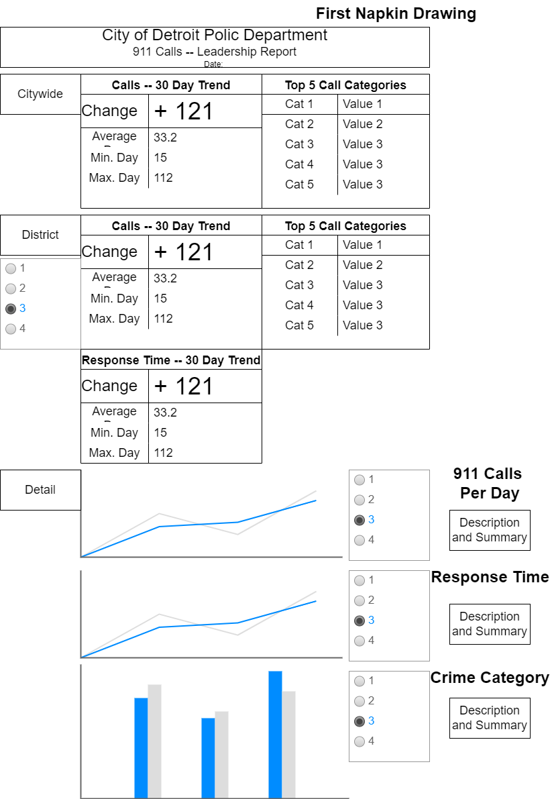

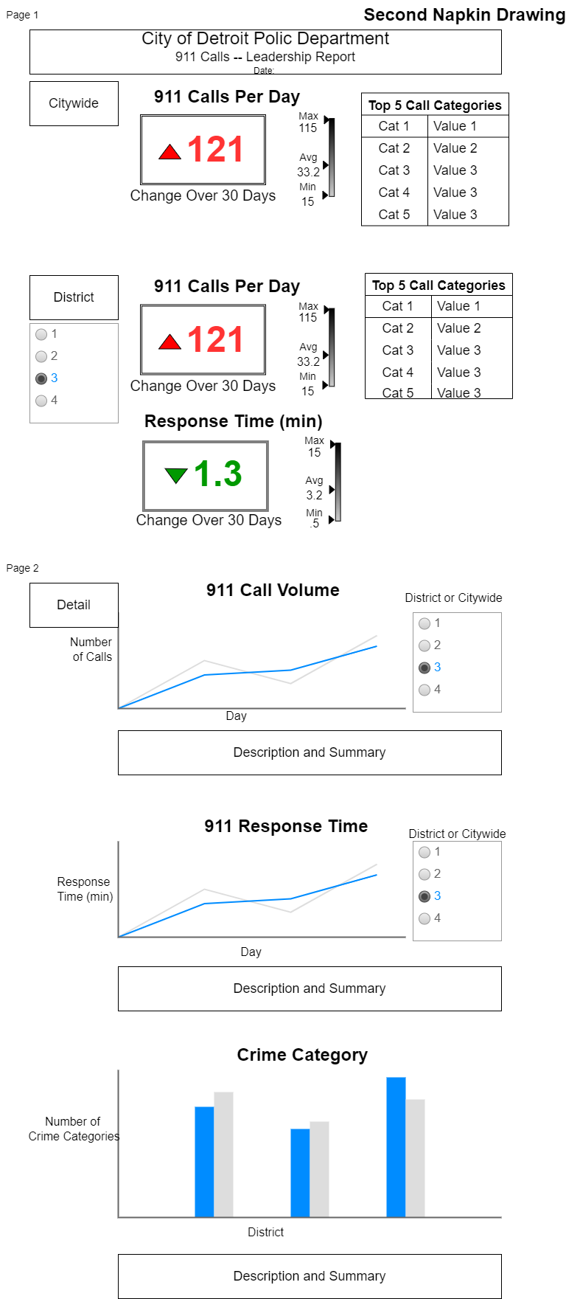

Feedback was that the top portion was too start and needed a graph or other element. I changed the min/max/avg to a graphic instead of a table to break up the layout.